ALLA KOMPANI

www.allakompani.com

Tips for the care & maintenance of window systems
Regular care, cleaning of the glass and profile surfaces and maintenance of the fittings are very important to maintain the value and guarantee the function of your Salamander windows. This ensures a long service life for the elements.

Care of the profiles & seals
- • Regular cleaning of the outer and inner sides as well as the rebate area
- • Fenosol" cleaning program for optimum window care available from your specialist dealer. With these special cleaners, your windows will be really clean and the antistatic effect will reduce re-soiling
- • To clean the window profiles, use only commercially available mild household cleaners (dishwashing detergents) without abrasive or scouring agents and without solvent-based ingredients. Caution: Do not use nitro thinner or scouring powder!
- • Always rinse with clean water
- • Annual inspection of the seals for damage and replacement by a specialist if necessary
- • Check and clean the seals for soiling from dust, pollen, etc.
- • Check the drainage facilities (slots and holes) for patency and carefully clean the openings if necessary

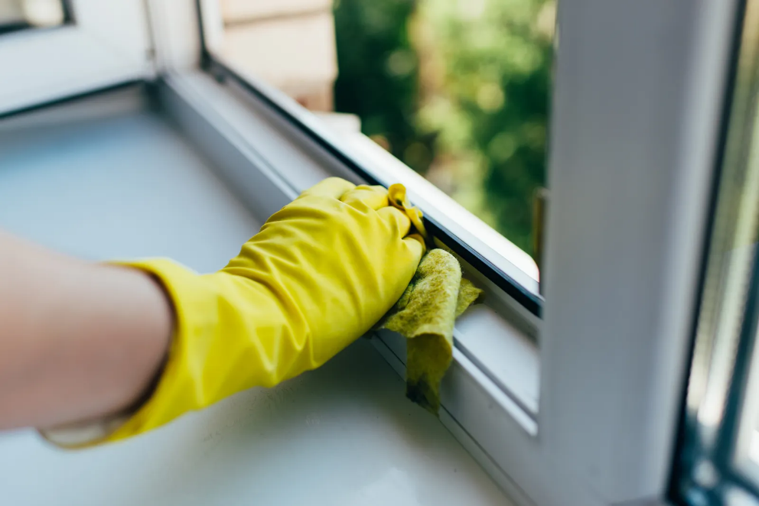

Care & maintenance of the fittings
- • Adjustment work on fittings and the removal and installation of window sashes may only be carried out by specialists
- • Fittings require regular cleaning
- • Quick, residue-free and problem-free removal of possible soiling on the hardware with the Salamander cleaning and care set
- • Available from your specialist dealer: Salamander cleaning and care set for white and colored windows
- • Annual inspection of all moving parts of the hardware for wear and tear
- • Grease the locking parts and locking pins, as well as scissor stay and corner bearings with technical Vaseline
- • Oiling the locking parts and locking pins, as well as scissor stay and corner bearings with maintenance sprays
- • Regularly check and, if necessary, retighten the hardware fastening screws

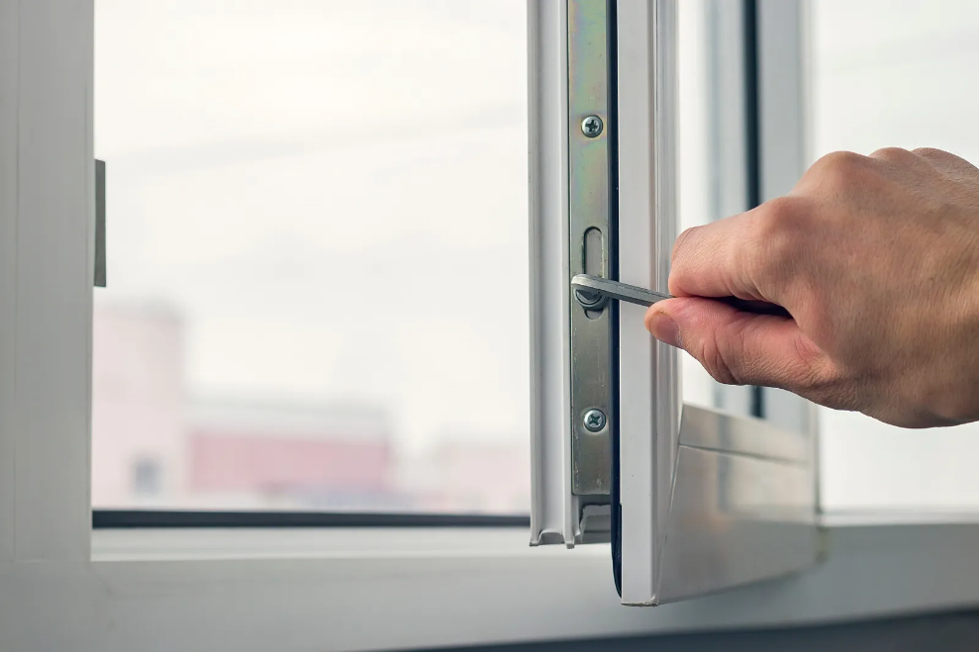

Handling window sashes
Do not place any obstacles in the area between the sash and frame and avoid placing any additional load on the sash. In addition, you should not press the sash against the wall - this can damage it.
Always ensure that you do not become trapped in the area between the sash and frame - especially with sliding doors.

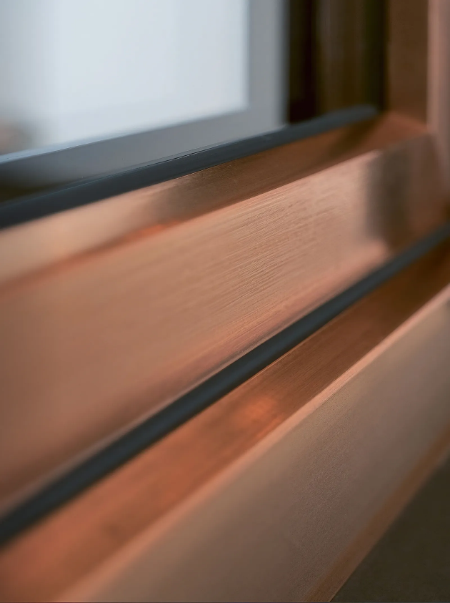

The right care for coated profiles
The best way to care for your film-laminated profiles is with water. If necessary, you can also use a standard household cleaning product or clean the profiles with glass cleaner diluted in a little water.
Ideally, you should first test the suitability of your preferred cleaning agent on a concealed area of your profiles. Make sure you use cleaners without spirit. Dirt cannot adhere to the smooth film of your coated profiles, so any dirt can be removed very easily and without the use of cleaning agents. Further care of your coated profiles is generally not necessary.

You should avoid these cleaning products
- • Dissolving agents; e.g. nail polish remover, alcohol or ammonia
- • Cleaning agents with orange, lemon or peppermint aroma
- • Agents containing sulphur or similar, e.g. tile cleaner
- • Abrasive agents, steel and scouring sponges and microfiber cloths

